**Dennis Tikhomirov DevOps training, Spring’19**

**Homework, Apache_Tomcat_HTTPd**

1. **Apache Tomcat**

**Linux version**

**1.1.  Install Tomcat on Linux and carry out p.1.2-1.12 of the task**

sudo mkdir /home/tomcat

cd /home/tomcat

sudo wget <http://ftp.byfly.by/pub/apache.org/tomcat/tomcat-9/v9.0.22/bin/apache-tomcat-9.0.22.tar.gz>

sudo tar -xf apache-tomcat-9.0.22.tar.gz

cd apache-tomcat-9.0.22

sudo ./bin/catalina.sh start

Screenshot#1.1. Tomcat is started

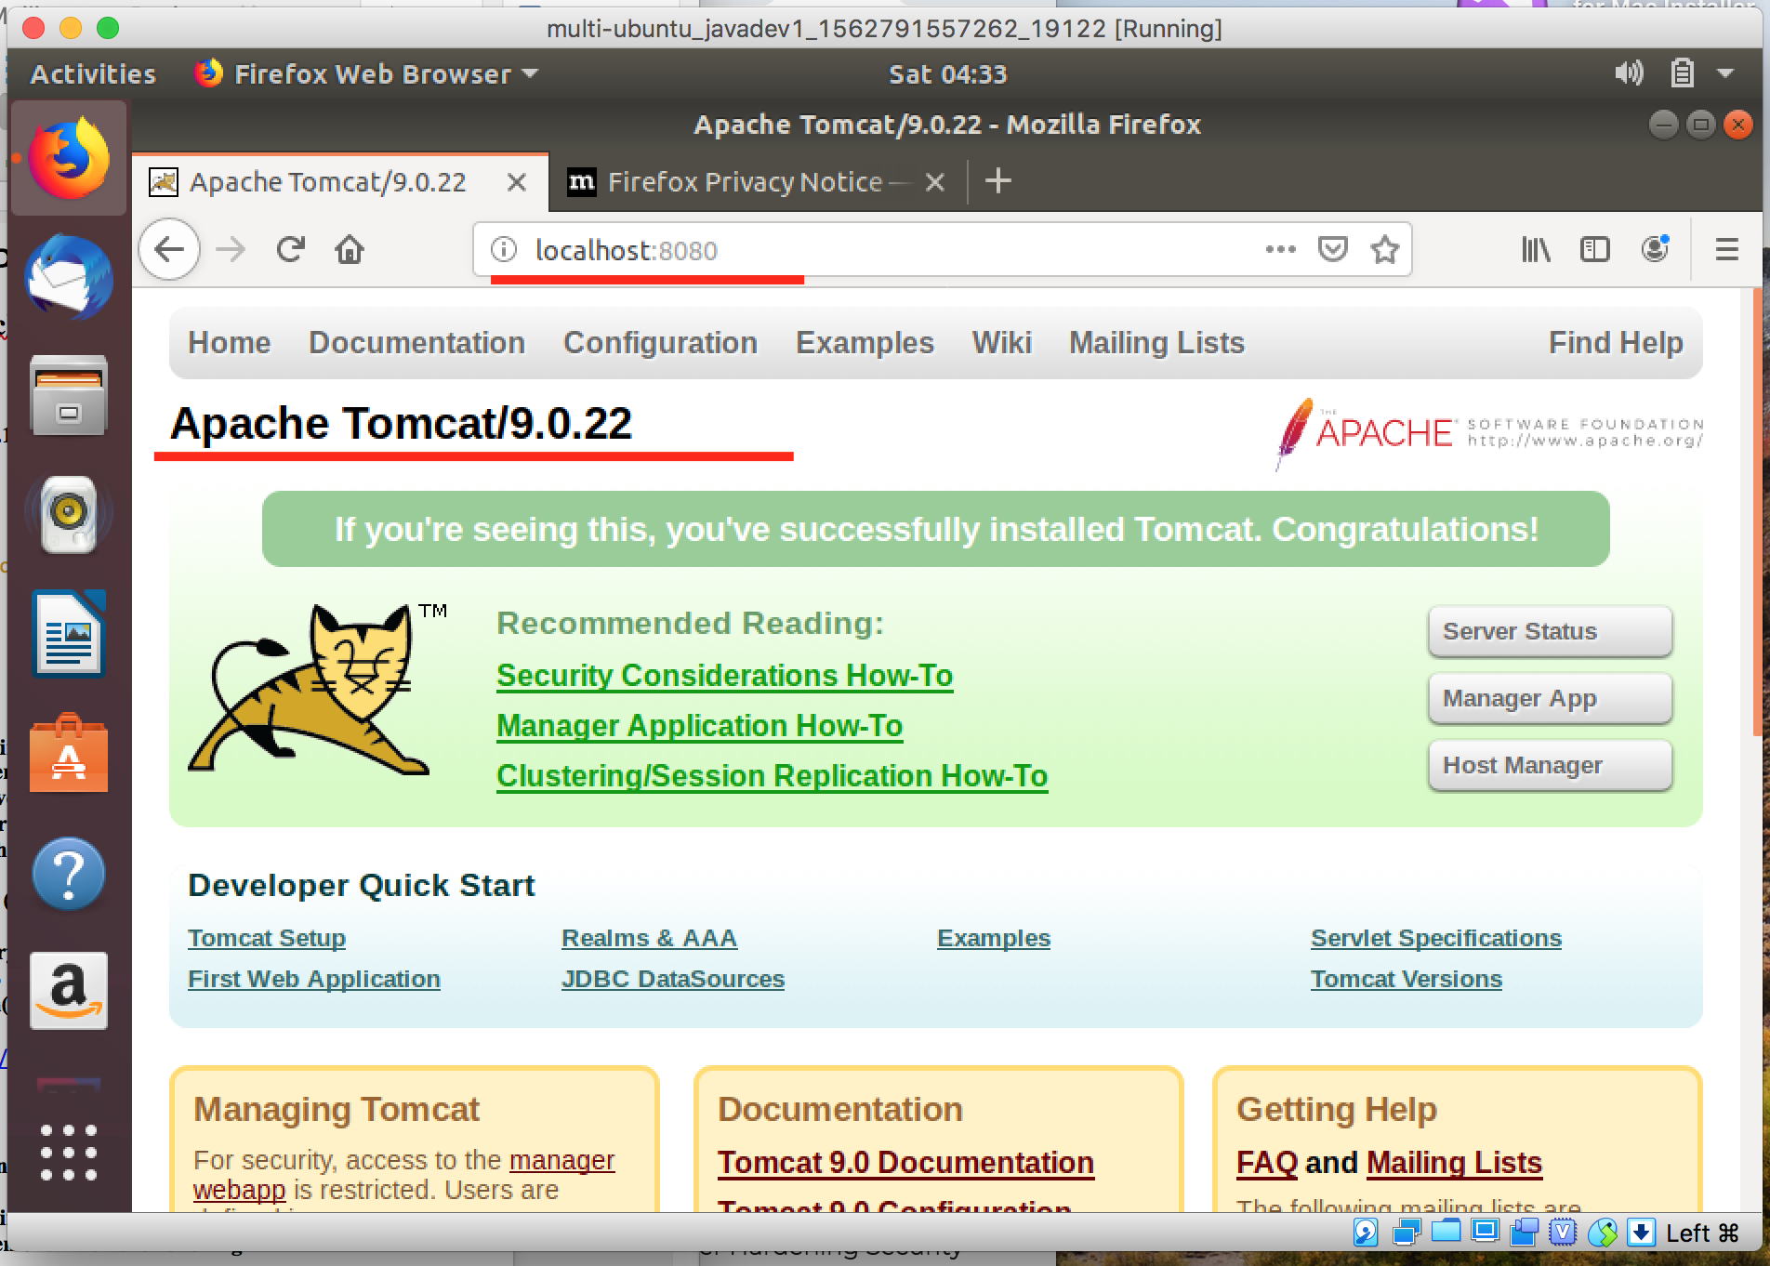

**1.2.  Create a Tomcat context**

**1.3.  Create a simple WEB application consisting of an HTML document and a servlet**

**1.4.  Deploy this application to Tomcat and demonstrate its functioning**

**1.5.  Pack this web application to a web archive**

**1.6.  Remove the deployed WEB application from Tomcat**

**1.7.  Deploy WEB application from WEB archive**

**1.8.  Change the Tomcat port to 5050**

**1.9.  Change the default application directory (webapps) to another and check that the directory**

**has picked up (i.e. applications in this directory are accessible via http)**

**1.10.  Write command scripts in Windows OS and Linux OS to execute p.1.4-1.9**

**1.11.  ConfigureApacheTomcatauthentication(standardHTTPauthenticationinTomcat.doc)**

About HTTP auth framework

<https://developer.mozilla.org/en-US/docs/Web/HTTP/Authentication>

**1.12.  Configure SSL for Apache Tomcat**

**Windows version**

**1.1.  Install Tomcat on Windows and Linux and carry out p.1.2-1.12 of the task**

**1.2.  Create a Tomcat context**

**1.3.  Create a simple WEB application consisting of an HTML document and a servlet**

**1.4.  Deploy this application to Tomcat and demonstrate its functioning**

**1.5.  Pack this web application to a web archive**

**1.6.  Remove the deployed WEB application from Tomcat**

**1.7.  Deploy WEB application from WEB archive**

**1.8.  Change the Tomcat port to 5050**

**1.9.  Change the default application directory (webapps) to another and check that the directory**

**has picked up (i.e. applications in this directory are accessible via http)**

**1.10.  Write command scripts in Windows OS and Linux OS to execute p.1.4-1.9**

**1.11.  ConfigureApacheTomcatauthentication(standardHTTPauthenticationinTomcat.doc)**

About HTTP auth framework

<https://developer.mozilla.org/en-US/docs/Web/HTTP/Authentication>

**1.12.  Configure SSL for Apache Tomcat**

**2. Apache HTTPd**

**2.1.  Install Tomcat on Windows and Linux and carry out p.2.2-2.7 of the task**

**2.2.  Make the file available via http**

**2.3.  Change root directory**

**2.4.  Change apache port to 70**

**2.5.  Make not root directory accessible via http (Alias)**

**2.6.  Configure Apache HTTP authentication (Apache basic authentication setup.doc)**

**2.7.  Configure SSL for Apache HTTP (Apache and SSL.doc)**

**2.8.  Create a VLAN containing two computers.**

**2.8.1.  Install Apache HTTPd and Apache Tomcat on the same computer.**

**2.8.2.  On the second computer, install only Apache Tomcat.**

**2.8.3.  Configure Apache HTTP + Apache Tomcat via mod_jk.so (Tomcat Apache**

**Configuration.doc) with load balancing**

**2.8.4.  Deploy a web application from section 1.5**

**2.8.5.  Demonstrate logs of query execution taking into account balancing**